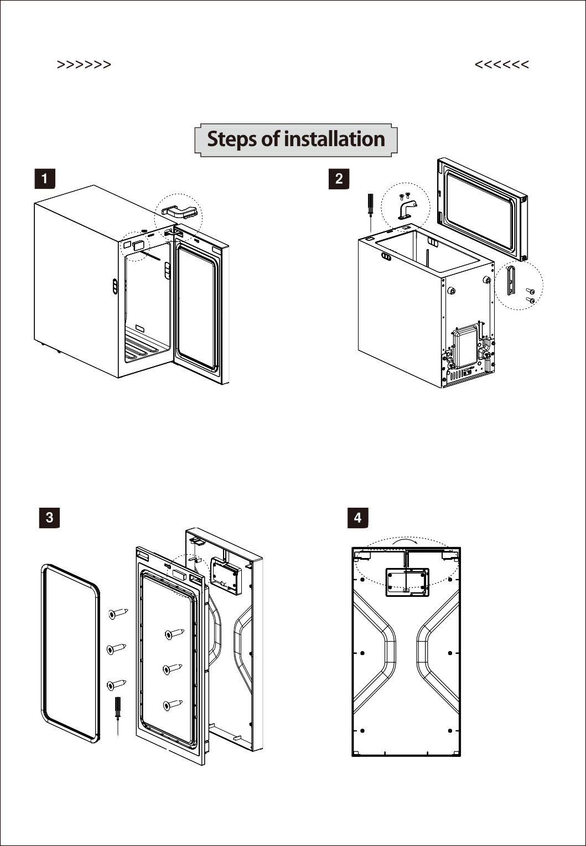
Reversible Door Installation Procedure
MC13 D

(1) Remove the door hinge cap and the right hinge cover; (2) Disconnect the display connection cable.

(1) Remove the door gasket and hinge cap;
(2) Use a screwdriver to remove the ST3.5x16 galvanized countersunk self-tapping screws (6 pcs) and remove the foam door assembly and door frame.
(1) Put the refrigerator as shown to prevent damage to the compressor, the time should not be too long.
(2) Use a screwdriver to unscrew the M4x10 countersunk head screws, black galvanized (2 pcs) and M5x16 galvanized semi-circular head screws with toothed washer screws (2 pcs) and disassemble the upper right door hinge and lower hinge.

(1) Place the door frame according to the drawing, remove the display wire from the socket and pass it to the right side.

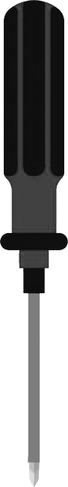


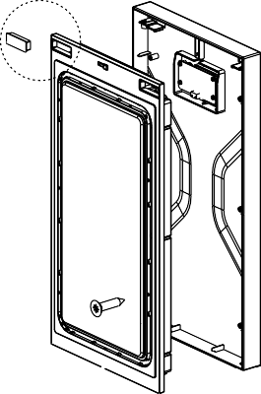

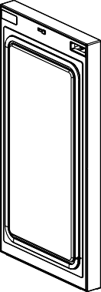
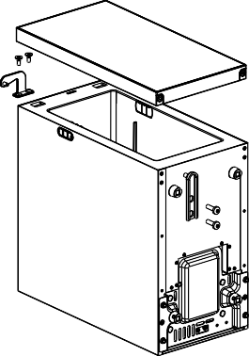
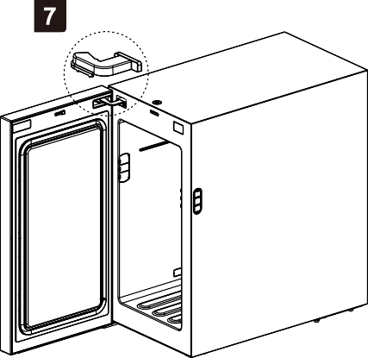
Reversible Door Installation Procedure
MC13D

(1) Connect the foam door assembly with the door frame;
(2) Use a screwdriver to screw the galvanized ST3.5x16 countersunk self-tapping screws (6 pcs);
(3) Install the top door hinge end cap on the left side of the foam door assembly (as shown);
(4) Insert the door gasket.
(5) The door is assembled.

(1)Lay the refrigerator as shown to prevent damage to the compressor, the time should not be too long.
(2)Match the hole of the upper door hinge with the door hinge and insert it;
(3) Align the lower door hinge with the hole of the lower door hinge and insert it, then use galvanized semi-round head screws
M5x16 with gear washers (2 pcs) and mount.
(1) Turn the refrigerator over and connect the display wire to the case;
(2) Remove the cover of the upper left door hinge from the accessory bag and secure the hinge as shown in the figure
REMARK:
Please put the removed parts back into the accessory bag for later use.

