Refrigerator – Compressor Milk Cooler Instruction Manual
Kitchenmaster
Model: MC13D

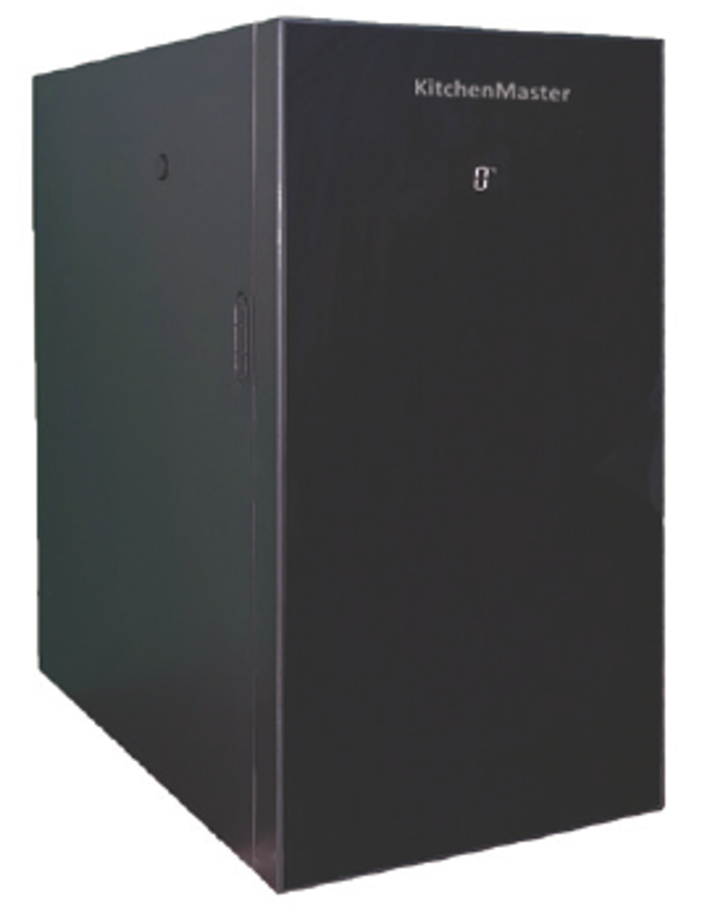

Table of contents
1. General information ................................................... 3
2. Specifications........................................................ 9
3. Installation...................................................................... 10
4. Maintenance.............................................................. 11
5. Troubleshooting................................ 11
6. Electrical diagram .............................................. 13
1. GENERAL INFORMATION
1.1 Introduction
The purpose of this manual is to provide important information regarding installation, use, and maintenance. Before using the appliance, please read the information in this user manual carefully.
The manufacturer accepts no liability for any damage resulting from misuse, installation, or failure to clean and/or maintain the product that has been performed in violation of this manual. With a view to constantly upgrading its products, the manufacturer reserves the right to note that the information contained in this manual may differ slightly from the modified versions.
1.2 GENERAL APPLICATION
 The refrigerator is not designed to be used outdoors in an environment
exposed to atmospheric factors (rain, direct sunlight).
This appliance can be used by children aged 8 years and above, and persons with reduced physical, sensory or mental capabilities, as well as persons lacking experience and knowledge, if they have been given supervision or instruction concerning use of the appliance in a safe way and understand the hazards involved. Children are not allowed to play with the appliance. Cleaning and maintenance must not be carried out by children without adult supervision.
If the power cord is damaged, it must be replaced by the manufacturer, its service agent, or a qualified person to avoid the risk of electric shock.
A device mechanically damaged during transport must not be plugged in.
Like any refrigeration appliance, the refrigerator should be transported vertically, according to the instructions on the carton.
Before connecting the device for the first time, set it up, level it in the place where it is to work, then wait a few hours before starting it. This action allows the refrigerant to stabilize, which can affect work efficiency. During the operation of the refrigerator, you may hear the sounds of compression and expansion of the refrigerant, which is a normal phenomenon.
WARNING: Do not obstruct the ventilation openings in the housing so as to allow free flow of air inside the refrigerator for cooling.
– WARNING: Do not use mechanical devices or other means to accelerate the defrosting process other than those recommended by the manufacturer.
– WARNING: Care must be taken not to damage the refrigerant circuit.
– WARNING: Do not use electrical appliances in the food storage compartments of the appliance unless they are of the manufacturer's recommended type.
 Caution: risk of fire/flammable materials
Do not store explosive substances such as pressure containers with flammable substances in this appliance.
Correct disposal of used product
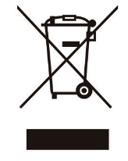 This marking indicates that the used product must not be disposed of with other household waste within the EU. To prevent possible harm to the environment or human health from uncontrolled waste disposal, waste must be recycled responsibly to promote the sustainable reuse of natural resources.
To return your used device, use the return and collection systems or contact the retailer where you purchased the product. Information on the location of selective municipal waste collection points can be found in the nearest municipality. A used refrigerator must be recycled in an environmentally safe manner.
Throwing away products marked with the symbol with other waste is punishable by high fines.

1.3 CONTROL PANEL AND DISPLAY
The refrigerator is shipped ready for use.
The temperature is set to 3°C at the factory
1.3.1 Control Panel
Lcd

SET. Increase T

On/Off Reducing T

Icon On/Off
When the power cord is turned on, a pulsing On/Off icon appears on the control panel. Other controls are not highlighted.
In off mode, hold the icon for 1 second to turn on. When turned on, all the lights on the panel light up and the display shows the current temperature inside the refrigerator.
In working mode, hold the icon for 3 seconds to turn off.
SET icon
Lightly tap the icon once to set the temperature inside the unit. The display will show the temperature value that has been pre-programmed. Press "  " or " " to adjust. Temperature range 0~4°C, factory setting 3°C. When you press " " or " " the screen will stop flashing for 2s. To program the selected temperature, touch the SET light. If you do not perform any operation for 8 seconds, the selected temperature value will pulse on the screen and then be automatically remembered.
Icon: Decrease T
In setting mode, it is used to reduce the temperature. Each touch decreases the value by 1. After a long press for 2 seconds, the value continues to decrease.
The optimal setting of the device is achieved when the temperature inside is set to 4° C. Most manufacturers of coffee machines recommend that you use milk cooled to 4° C to prepare lattes, cappuccinos and macchiatos. Cooling below this temperature may cause the first ice crystals to precipitate, which may affect the patency of the milk system of the coffee maker, and higher energy consumption by the refrigerator.
Icon: Increase T
When the display pulses, each tap of the Icon increases the value by 1; After a long press for 2s, the value continues to increase.
1.3.2 Display LCD

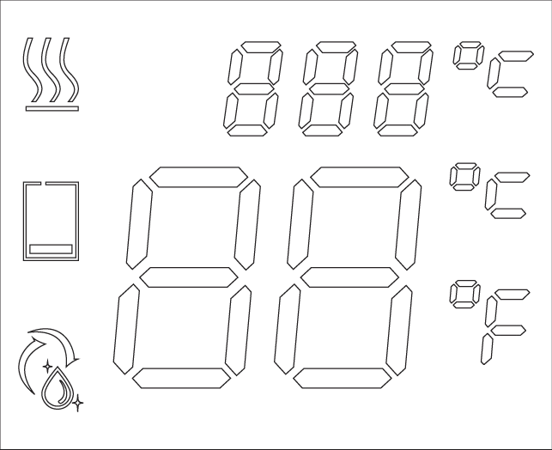

No milk indicator light
Temperature display

No milk: Feature only available with optional milk containers (does not work when using milk in a carton). Accessory containers to be purchased separately. Models PM 2.5 , PM 4.5 , PM 4.5S. When the container is low on milk, the milk icon flashes. An acoustic milk shortage alarm is then automatically triggered. The device then emits 2 acoustic signals every 4 seconds and the indicator light on the display flashes. The maximum time for transmitting acoustic messages is 10 minutes. After this time, the alarm will be turned off while the indicator light on the display continues to flash. The acoustic alarm can be turned off by tapping the SET icon on the control panel. Refilling the contents of the milk container automatically turns off the alarm and the icon on the display.

Device lock: After 30 seconds, the device locks and starts working within the set parameters.
Multi-function display: In the event of a device failure, the display displays error codes
E1: Refrigerator Temperature Sensor Failure E2: Milk Temperature Sensor Failure
1.3.3. Connecting the milk line of the espresso machine to the refrigerator.
The refrigerator has two holes on the left and right walls for connecting the milk line. The diameters of the holes can be adjusted using appropriate reductions. Care should be taken to use the appropriate diameter reducers to ensure the greatest possible tightness of the connection. Leave all unused openings plugged in, which affects cooling efficiency and electricity consumption.
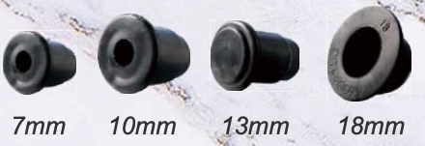

1.3.4 Door with lock
The front door of the device is equipped with a lock so as to limit access to the interior for unauthorized persons. Two keys are included.
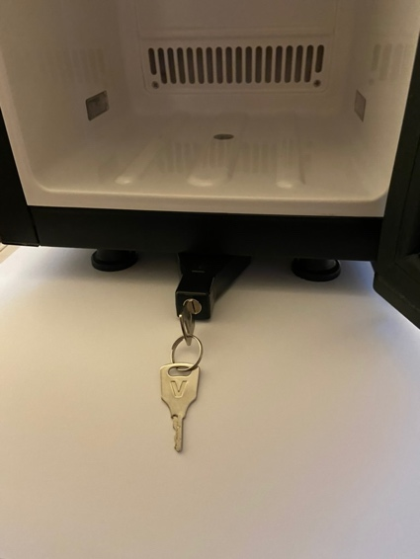
1.4 USER RESPONSIBILITY (BEFORE YOU CONNECT THE APPLIANCE)
Be sure to check that the electrical outlet is connected to the ground and has a voltage consistent with the values stated on the rating plate. Make sure the refrigerator is positioned on a horizontal stable surface.

2. SPECIFICATIONS

Model | Kitchenmaster MC13D
Tension | 220-240 V
Frequency | 50-60 Hz
Current | 0.5 A
The power of indoor lighting | 0.5 W
Refrigerant / quantity | R 600a/10.5 grams
Climate class | 3,4,5 (up to +40°C operating environment)
Net/ Gross Weight | 15kg/ 18kg
Total capacity | 13 L
External dimensions (mm) | (W x D x H) 230 x 450 x 456
Usable dimensions of the cooling chamber (mm) | (W x D x H) 180 x 225 x 360
Carton Dimensions (mm) | (W x D x H) 300 x 530 x 565
Temperature control range | 0 – 6°C

2.1 MATERIALS AND REFRIGERANT
Internal and external surfaces in contact with stored
products are made of galvanized steel, aluminum and non-toxic plastics.
The refrigerant used complies with current EU requirements.
The type and amount of gas with which the cooling system of the device has been filled is indicated on the nameplate.
3. INSTALLATION
To ensure safe and proper operation, follow the manufacturer's instructions in this section.
3.1 POSITIONING
Place the refrigerator in a properly ventilated room. Keep away from heat sources such as heaters or air conditioning pipes. Allow free air to flow into the refrigerator.
The ambient temperature must not be higher than 40°C. This climate class of the device is 3,4,5.
Climate class | Temperature C | Vigilance % | Dew point C | Water quantity  g/kg
0 | 20 | 50 | 9.3 | 7.3
1 | 16 | 80 | 12.6 | 9.1
2 | 22 | 65 | 15.2 | 10.8
3 | 25 | 60 | 16.7 | 12
4 | 30 | 55 | 20.0 | 14.8
5 | 40 | 40 | 23.9 | 18.8
6 | 27 | 70 | 21 | 15.8
7 | 35 | 75 | 30 | 27.3

3.1.1 Leveling the refrigerator: To ensure the best performance, the appliance must remain level. Four adjustable feet are used for this purpose
3.2 ELECTRICAL CONNECTION
WARNING DO NOT USE EXTENSION CORDS
The refrigerator operates on a single-phase power supply with a voltage of 220-240V/50Hz.
To switch on the refrigerator, insert the plug into the socket.
Make sure that:
The electrical socket is equipped with an earthing connection and the voltage and frequency of the electrical connection correspond to the values indicated on the rating plate. If you are unsure about the performance of the ground, have the electrical connection checked by a qualified technician.
When the refrigerator is operating, check that the supply voltage does not drop or rise below/above +10% of the rated voltage (187V to 242V).
The manufacturer is not responsible for damage or accidents resulting from misuse or failure to comply with the electrical regulations of the country where the refrigerator is used.
4. MAINTENANCE
- Always remember to unplug your refrigerator before cleaning it.
- Always unplug the refrigerator from the electrical outlet with a dry hand and never pull on the power cord only on the plug.
- Do not use sharp objects for cleaning.
- Clean the inner casing of the refrigerator with a clean, damp cloth or with a mild detergent. Avoid damage, never use abrasive or flammable cleaners.
- At least once a month, clean the rear vent grille with a vacuum cleaner or brush to eliminate dust build-up.
- Do not wash the refrigerator with a direct or high-pressure water jet.
When the relative humidity exceeds 55%, water condensation occurs on the inside of the door. This is normal and inevitable.
5. TROUBLESHOOTING
Often, problems that occur during normal operation can be solved without the help of a specialized technician, check the following:
a) The appliance does not work.
-Check that the plug is correctly inserted into the electrical outlet. -Check that there is voltage in the electrical outlet.
b) The product is too warm.
-Check the temperature setting on the control panel and raise it to 4°C. Check the door lock and make sure the door gasket is tight. Check that the internal fan is working and not blocked. -Check and clean the rear air vent, make sure all air vents are unobstructed.
c) The device is operating too loudly.
-Check that the equipment is level.
-Make sure that the equipment does not touch other equipment, it may cause vibration.
If you want to report a problem to the service, be prepared to answer the following questions:
-Problem Type: (Electrical, Mechanical)
-The model, code, and serial number can be found on the nameplate located inside the cooling chamber of the unit.
5.1 Warranty
The seller is liable under the warranty or warranty. The warranty does not cover elements that are subject to natural wear and tear, such as rubber gaskets, light bulbs or heating elements damaged by limescale, as well as components damaged as a result of improper and inconsistent with the instructions for use, including mechanical damage. Breaking the warranty seal or repairing it yourself automatically means losing the warranty.

6. ELECTRICAL DIAGRAM

